March 11, 2022 NJCOMO Teleconference Call Meeting Minutes
This meeting was called to order by Chris Massey
Attendee’s:

Sebin Vadassenl, Jennifer Brown, Lauren Fleming, Carrie Gerber, Jacqueline Cavelli, Kerry Quinn, Sami Abade, Martha Leveille Eileen Allen, Tia Sheck, Kathleen Perez, Judy Miranda, Lauren Hodges, Kathy Taylor, Alexa Shelly, Kathleen Yhlen

AGENDA DISCUSSION DECISION - REFERRAL
Recognition / Site visit
Analyst Questions
2021 Achievements  2022 Goal Statement  2022 Objectives | Achievements reviewed- removed Planned a Magnet Conference meet and greet activity as this was not accomplished due to COVID restrictions  Committee agreed to keep the Goal statement the same as 2021  1-7 state the same from last year  Added: Plan a professional development opportunity for the Magnet Program Director/Pathway Coordinator Role.
Troublesome SOE
2023 Manual  OO1  OO2  OO3  OO4  OO5  OO6  OO7  OO8  OO9  OO10  OO11  2023 TL  2023 SE | 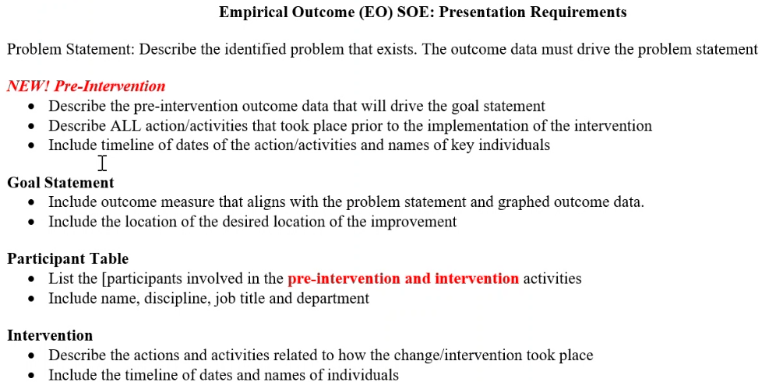  No changes  No changes- If you are part of a system but applying as an individual campus you must have campus specific data  No changes  No changes  Provide a description of the policies, procedures, charters or bylaws of the organization's shared decision-making structure. Provide a description of nursing’s structural and operational relationship within the organization shared decision making structure  No changes  Added equity and inclusion & zero tolerance for bullying, incivility and workplace violence. See ANA Position Statement on incivility, bullying and workplace violence.  Provide the policies, or equivalent evidence of, that depict the organization's initiatives for patients and families , regarding the following issues:  - Diversity, equity and inclusion  - Cultural competence  No changes, old OO8  Old OO9- IRB- choose the option which is applicable to the organization  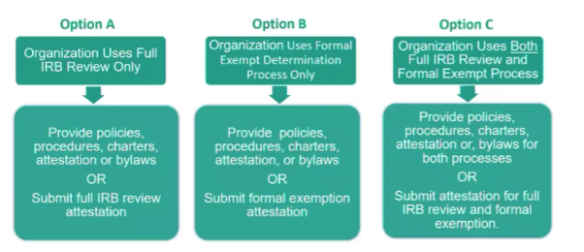  Old OO10- You will need to identify which studies are used for NK2, NK3a or NK3b-place next to study title in parenthesis on Research Table  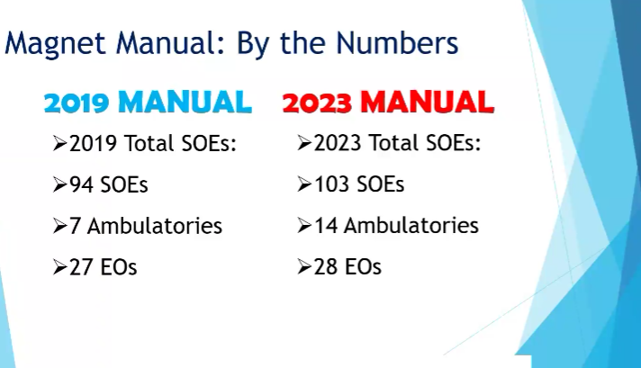  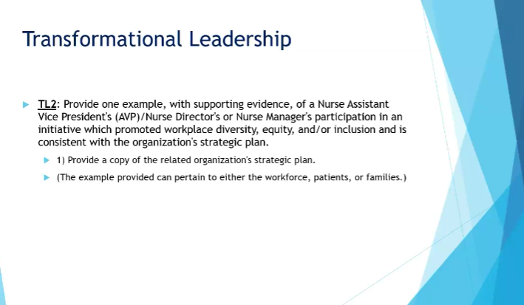  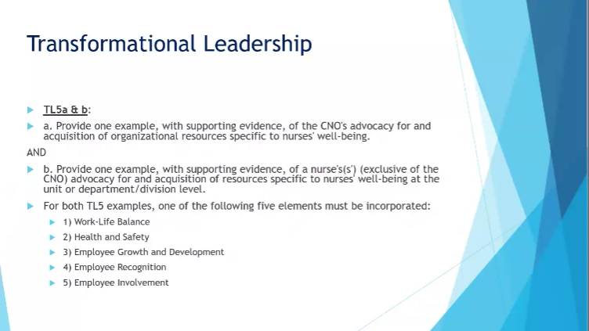  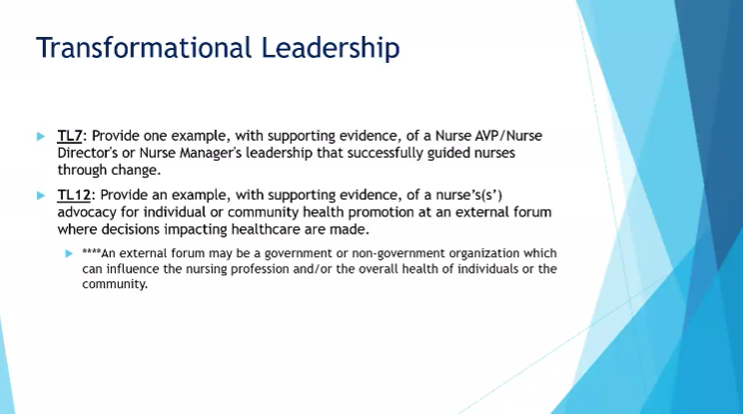  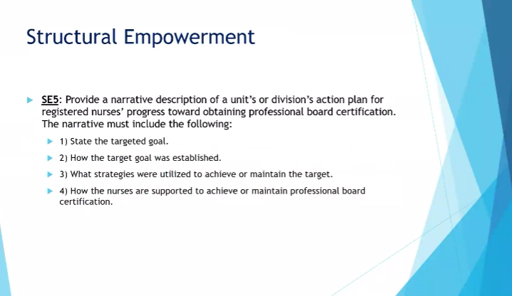
DDCT / Interim Reporting Issues Concerns
 | 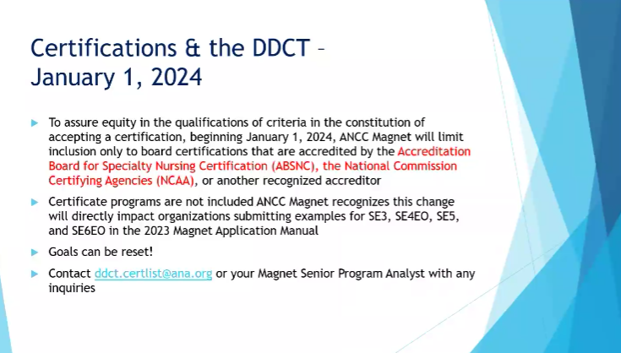
Innovations
 | 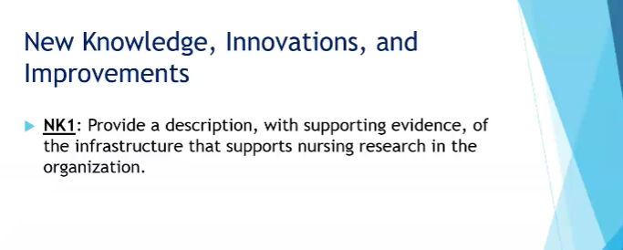
Additional Topics
 | 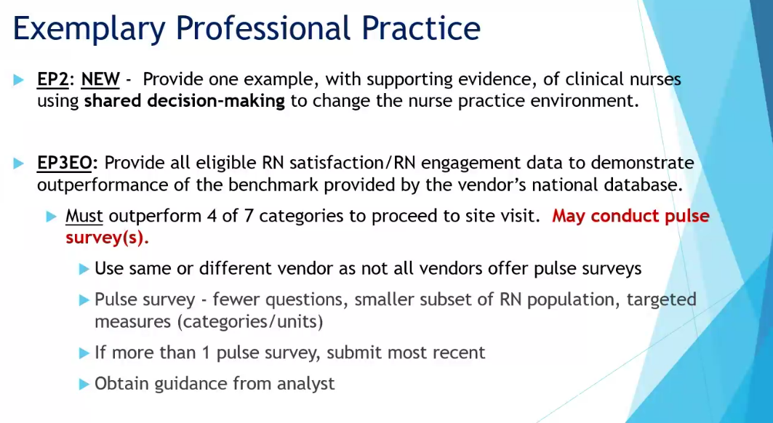
 | 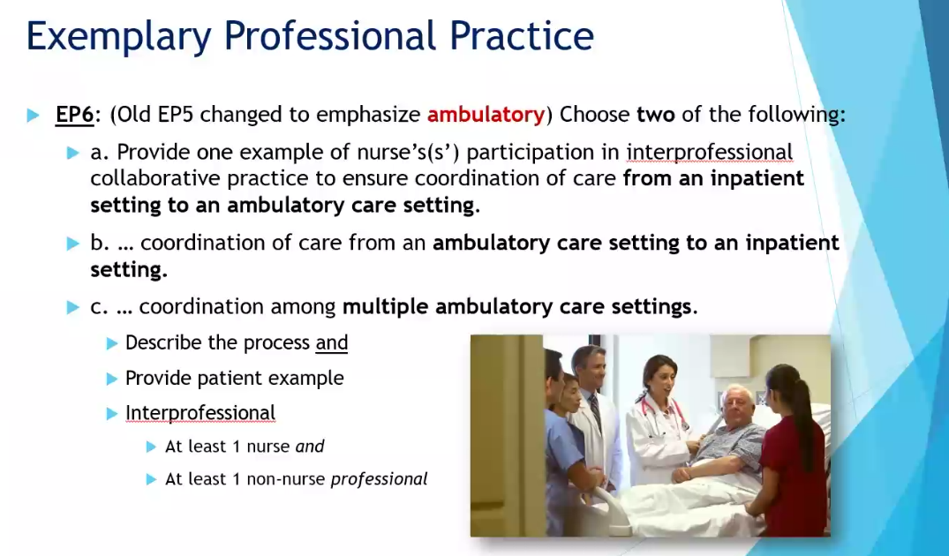
 | 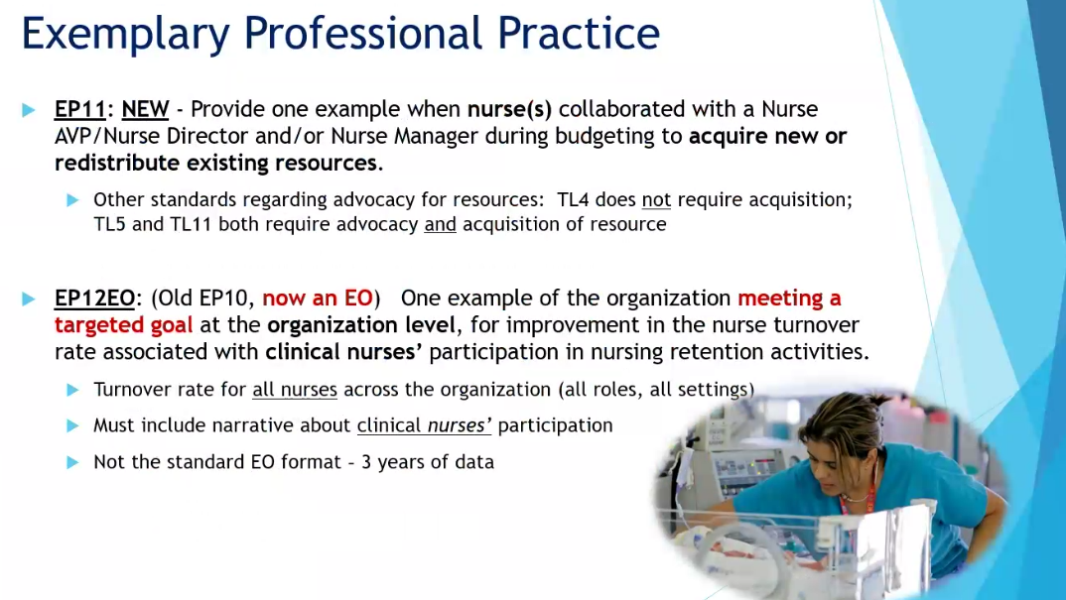
 | 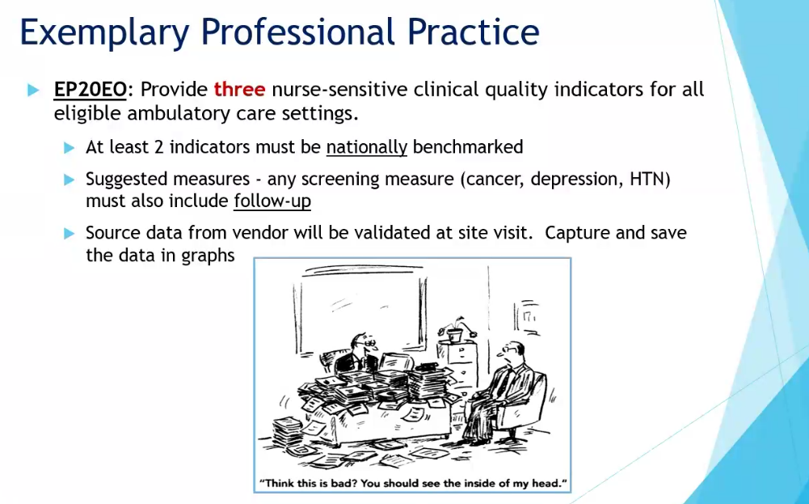
Next Meeting
Respectfully Submitted by: Kathy Taylor, DNP, RN, CCRN, CAPA, NEA-BC

